TE WHARE TAPERE O MATARIKI –
Tāmaki Makaurau Intermediate Kī o rahi Regional Tournament Rules

Ki O Rahi General Rules

1. 8 players per team on the field. Four females and four males on the field at all times.
2. No tackling, pulling on clothes, etc for this particular event. i.e. non contact!
3. Once a tag has been ripped off, the player has 3 seconds to pass the ball.
4. Players must have both tags on their belts before they can resume play.
5. If a player has both tags removed – double tag by one opposing player at the same time while in possession of the Ki, this will result in a loss of possession and handover.
6. This is a very fast game so time-wasting will result in a handover to the opposition.
7. Non-marking sole shoes must be worn during games.
8. No shorts with pockets. Tag shorts are allowed at your discretion.
9. In the case of a draw in the Semi final and finals the referee will NOT stop the game and will keep going until the first team scores – golden point.
10. Games are 5 mins quarters, 1 min halftime break.
11. Substitutes can occur during game as once the subbing player has left the field of play
12. Change over times between games is 2 minute so teams must be ready to take the court as soon as hooter sounds. Points will be given to opposition for every minute late your team is. If after 5 minutes the team still has not taken court that game will be defaulted.
13. The game starts with ki oma kicking the ball from the “marama” zone into the ki oma kaitiaki in pawero who throw it out again to their team members in the Te Ao zone. If the ball does not go into the Pawero, it is a handover to the Taniwha team.

Ki oma team – team defending the tupu

- No more than 2 players defending the tupu. They are allowed to join their team mates in the Te Ao zone but it must be through Te Ara, they cannot carry the ball out from Pawero, Te Ara into Te Ao zone.
- Ki oma cannot enter the Te Roto zone (middle zone) unless they are running into the Pawero zone (centre zone) to score a point or they are in no way interfering with the run of play and are making an effort to get out of the Te Roto zone.
- A point is scored by the ki oma team when the pou is touched by the ball carrier(s) and the ball is carried from the Te Ao zone through Te Roto and the player has touched the ball down in the Pawero Zone. Ki oma can also receive the ball in mid air eg jumping no feet touching ground, of Te Roto to score in Pawero.
- If a “try” is scored by ki oma, the restart goes back to the “marama” zone.
- If a tag is pulled off by an opposing player while they are in the Te Roto zone, the ball will be handed over to taniwha team.
- If ki oma touch a pou with any tag off, pou will not count.
- If ki oma lose possession of the ki and it is touched or possession gained by taniwha the number of pou touched goes back to zero.
- Kaitiaki have 5 secs to pass the ball back out to Ki Oma team members, if not handover to Taniwha team.

Taniwha team - team attacking the tupu

- Taniwha team can only enter the Pawero zone when jumping from Te Roto to attempt to shoot the tupu, must release the ball before landing in Pawero zone.
- Taniwha team must exit Pawero at point of entry.
- A point is scored by the Taniwha team when the ki touches the tupu, including own goals by Ki Oma kaitiaki. The ball is still alive when the ball rebounds off the tupu – there is no re-start.
- Taniwha feet ‘on’ line is NOT DEEMED OFFSIDE, feet must be over the line for offside
- If tag is ripped off by ki oma before attempting to shoot for the tupu, player must pass, point will not count.
- Only 5 Taniwha players are allowed in Te Roto at anytime.
- Taniwha have 5 secs to attempt a shot at the tupu once ki is in Te Roto, if not handover to Ki Oma team. If the ball is carried from Te Roto to Te Ao zone deliberately the 5 sec count will NOT restart.

Note for referees / scorers / school representative:

      - Schools are advised to take scores during the game, clarify with scorer at half time & full time to avoid any confusion over the final score.
- Referees to indicate number of points scored by raised hand and numbers of fingers held up to assist scorer / school rep.
- Any dispute in a final score, school rep to go straight to Admin desk to report, Scorer / Referee / Opposing team school rep, will be asked to come to Admin desk asap to clarify any disputed score. HOP Tournament Admin will make final decision and will stand.

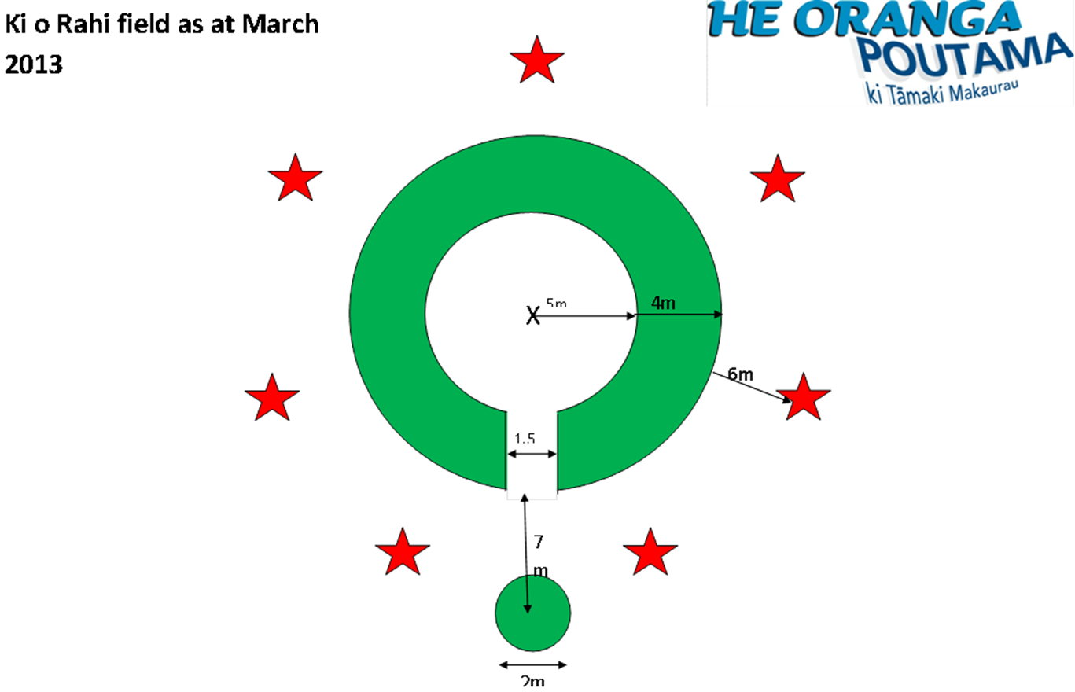
Te Whare Tapere o Matariki 2016
Ki o rahi field dimensions

